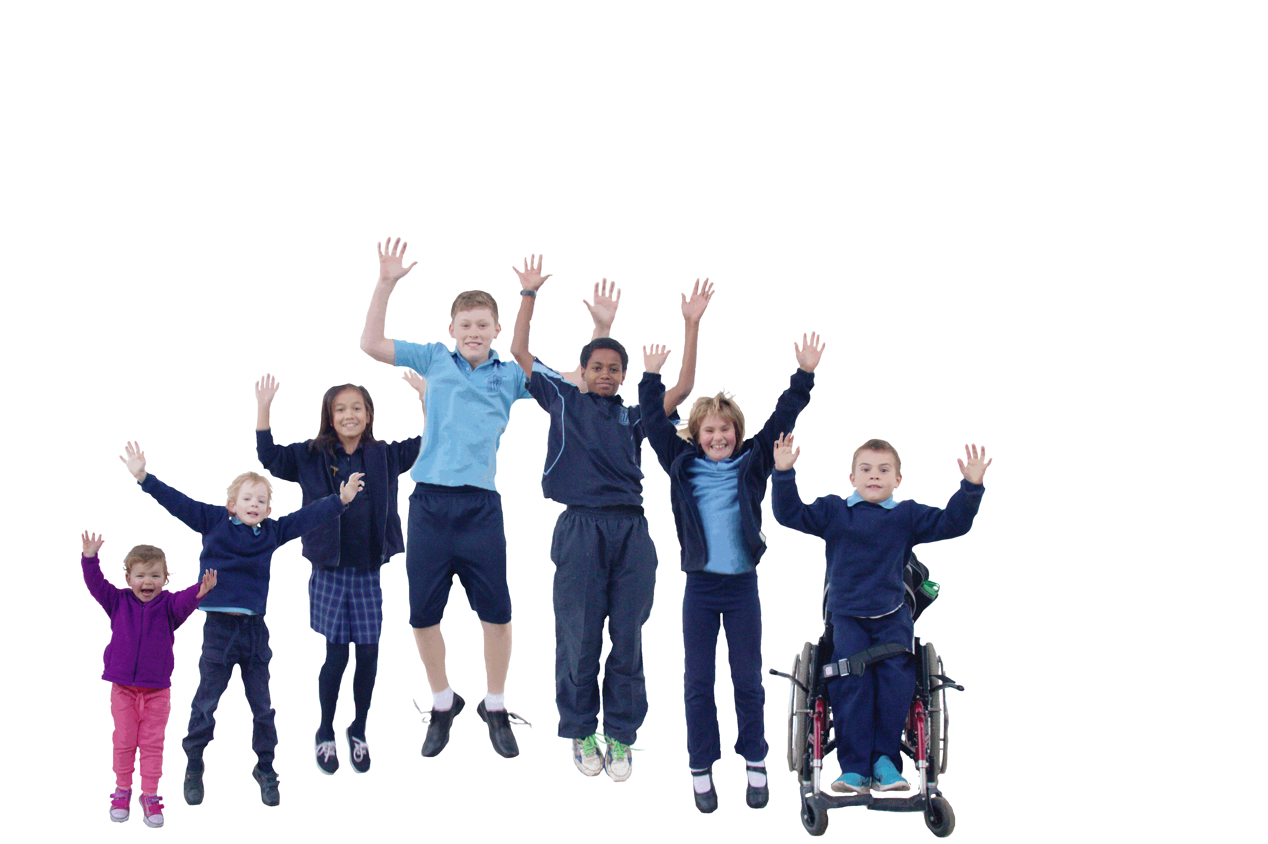
Ainslie School P- 6 Curriculum Framework Map 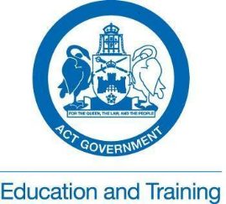
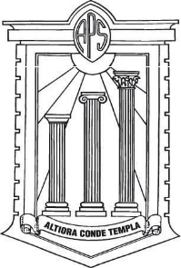
Every Chance to Learn Curriculum Framework- ACT ETD
Australian Curriculum - ACARA
Early Years Learning Framework - ACECQA
Ainslie School Curriculum Guide 2014
Formative assessment toolbox

Style Guides
AC Cross Curricular perspectives
Ainslie School Beliefs and Practices

Pacing Guide
AC General Capabilities

Learning Through Play K-1 @ Ainslie

Assessment and Reporting
Primary and secondary program guide
Guaranteed Curriculum Power Standards
I can… Statements
Pedagogy
Learning
School Report
A-E ETD
Assessment Schedule

Balanced Literacy Approach
writing, reading, phonics, sight words, spelling, phonological awareness, viewing

Balanced Numeracy Approach
CMIT, MYMC, Rich tasks, SENA I & II, problem solving, number, measurement, space & data

Student Portfolio
Learning Journey
Assessment schedule
Parent conferences

UbD INQUIRY FRAMEWORK
At Ainslie the inquiries students undertake incorporate content from these learning areas:
History
Geography
Science
Health
Technology
At Ainslie these learning areas both stand alone and are part of the inquiries students undertake:
English
Mathematics
The Arts - Music, Visual Art, Dance and Drama
Physical Education
Japanese language and culture
General capabilities
Cross curricular perspectives

Valued Strategies for enhancing learning in our classrooms
- Create a pro-learning, pro-reading, pro-writing ethos
- Make explicit (bring to conscious awareness) reasons, purposes, processes
- Let kids in on the secrets of how learning ‘works’
- Model, demonstrate, think aloud
- Set up conditions which allow kids to ‘talk their way to meaning’
- Value learners. Value their beliefs, knowledge and the language they bring with them
- Provide authentic learning contexts- real learning for real purposes
- Create a safe environment where students are encouraged to take risks with their learning

Educators draw on their values, professional knowledge and skills as they pay close attention to the interrelated pedagogical practices outlined in the Early Years Learning Framework: ‘The EYLF has a specific emphasis on play-based learning and teaching.’
◆ holistic approaches
◆ responsiveness to children
◆ learning through play
◆learning environments
◆ intentional teaching
◆ cultural competence
◆ continuity of learning and transitions
◆ assessment for learning.

