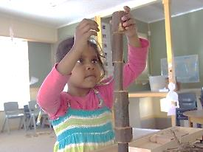
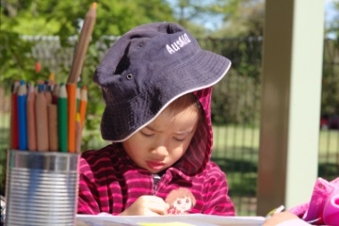
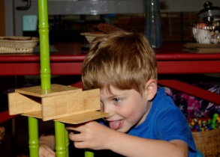
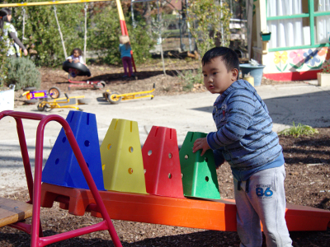
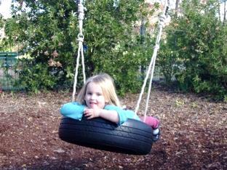
Our Philosophy

Ainslie School Preschool Units are dedicated to providing high quality, child centred, play based early childhood education. As such, our educators are guided by the vision, principles, practice and learning outcomes of Belonging, Being and Becoming - the Early Years Learning Framework, to develop a curriculum in which children are encouraged and supported to develop a strong sense of identity and wellbeing, connect with and contribute to their world, become confident and involved learners and effective communicators.

Educators in our preschools believe that all children are rich in potential, capable and
competent learners. Educators recognise children's agency, capacity to initiate and lead learning, and their rights to participate in decisions that affect them including their learning.

We believe play is the way in which children connect with one another, explore,
understand, communicate, learn, discover, imagine and create. Educators believe that
children's learning is dynamic, complex and holistic. As such in our preschools children are encouraged and supported to actively pursue and construct their own understandings and contribute to others' learning. Children are given space and time to play in aesthetic and sustainable environments that are designed to reflect, nurture, stimulate, inspire and challenge and resourced with materials rich in possibility. Documentation is an important feature of our practice and used to record and share learning, for reflection and planning.

Educators in Ainslie School’s Preschool Units respect families as a child’s first and most important educator. We believe that children thrive when families and educators work together in partnership. As such, meaningful partnerships based on mutual trust and open communication are developed and sustained in safe, healthy and inclusive environments.
We believe that connecting with the local community is a critical aspect of children's
education and development. We value and celebrate the cultural diversity of our preschool community and seek to share in Aboriginal and Torres Strait lslander ways of knowing and being.

We believe that children should be encouraged and supported to connect with nature.
As such children regularly participate in walks in the local area, excursions to our cultural institutions using public transport, caring for our vegetable garden and our chickens.

We believe that qualified educators who develop and sustain professional and respectful relationships with each other, children and families are pivotal to effective teaching and learning. As such our educators are encouraged and supported to reflect on their practice personally and within Ainslie School’s professional learning community.
