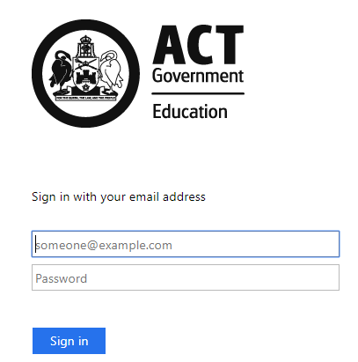
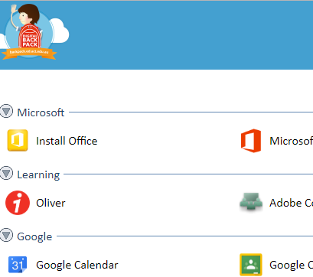
How to borrow an e-book

- Go to https://backpack.ed.act.edu.au You need to be signed in to borrow an eBook.

- Click on the Oliver icon

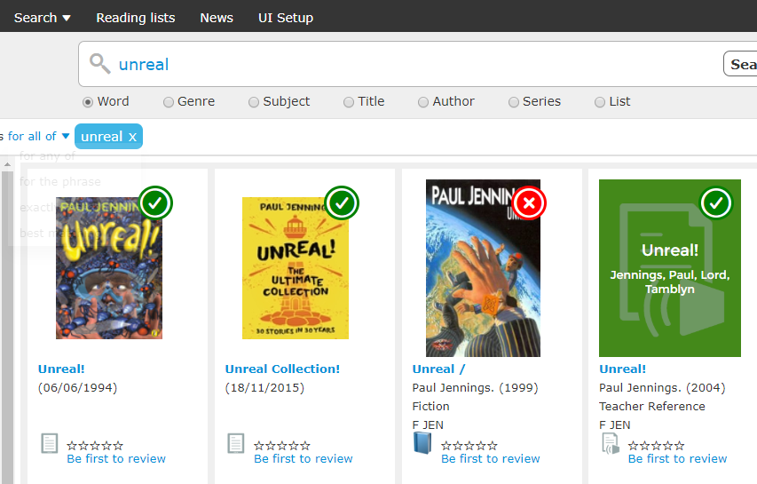
Type your book in here
These are eBooks
This is an actual book
This is an audio book

These can be borrowed - they are ‘in’
This cannot be borrowed - it is ‘out’
- Search for a book that you would like to borrow

- Look at the symbol underneath the books. This is an ebook. This is an actual book
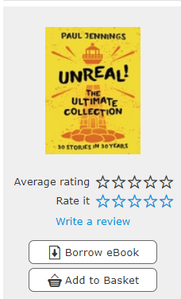

- Click on the ebook you would like to borrow.

- When the window opens, on the left hand side under the picture you have the option to ‘Borrow eBook’. Click on it.

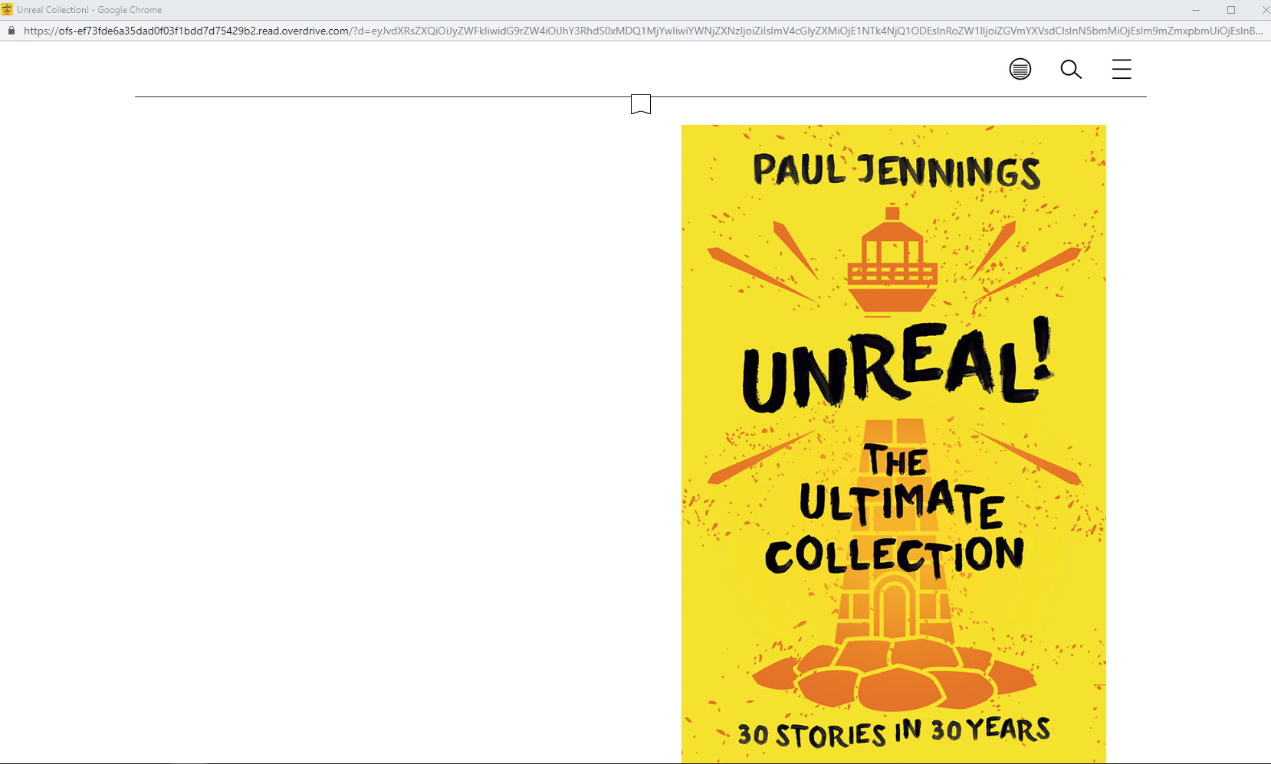
- A new window will open up - this is your eBook. You can read it now, or come back to it later (see instructions below).

To read an e-book at another time

- Go to https://backpack.ed.act.edu.au You need to be signed in to find your eBook.

- Click on the Oliver icon

- On the right hand side, click on your name and then Loans
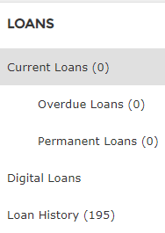
- On the left hand side, click on digital loans
Fred

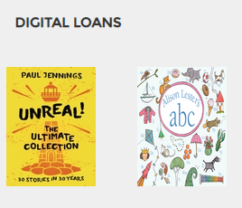
- Click on the book that you would like to read

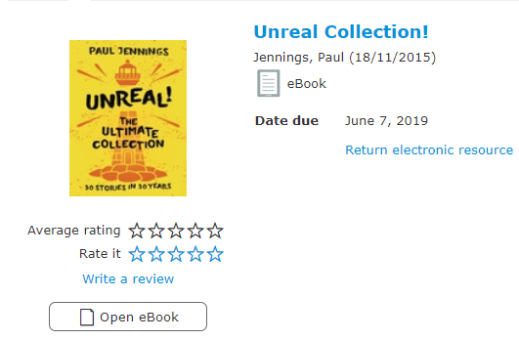

- Click on Open eBook. You can now start reading again.

- Below are you options when reading the book
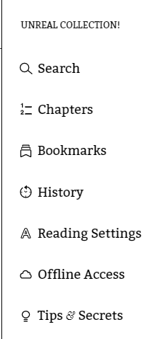
Bookmark
1 or 2 page view
Search this book
Index

