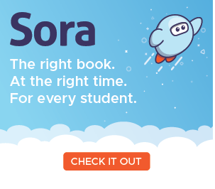

# Getting started with Sora!!!

With Sora, you can borrow free e-books and audiobooks from the central **ACT Education Directorate** collection. More than 8,000 e-book titles and 1,000 audiobooks available for recreational reading. Borrow up to 10 resources at a time! Loan period is two weeks with an early-return option for those quick, enthusiastic readers. Need a bit more time, then use the renewal option if no one has placed a HOLD (reserve).

## Step 1

Go online to [soraapp.com](https://soraapp.com/). or install the free Sora app from the [Apple App Store](https://itunes.apple.com/app/sora-by-overdrive/id1376592326?pt=211483&ct=HelpSoraArticle_5033&mt=8) or [Google Play Store](https://play.google.com/store/apps/details?id=com.overdrive.mobile.android.sora&utm_source=help_sora&utm_medium=article5033&utm_campaign=odapp)

## Step 2

In Sora, in ***Find My School*** enter the set-up code **ACT Education Directorate (NOT the individual school’s name)**, then, sign in using your school, individual login credentials, ie. student ID number and password or the staff Schools net account and password.

## Step 3

Browse the tab and borrow an e-book or audiobook. Your book will open so you can start reading or listening right away.

## Step 4

Close the book and go to & see all your books (up to 10!). From there you can:

* Select **Open book** or **Open audiobook** to read or listen to the book.

1. Select **Options** to renew or return the book.